## Bachelor’s Thesis Project

For the completion of Bachelor’s Degree In Mechanical Engineering

*Report Compiled By* Utkarsh Sharma (16ME33017)

*Under the guidance of*

### Prof. Goutam Chakraborty



DEPARTMENT OF MECHANICAL ENGINEERING INDIAN INSTITUTE OF TECHNOLOGY, KHARAGPUR

1

## Department of Mechanical Engineering Indian Institute of Technology, Kharagpur



**CERTIFICATE**

This is to certify that this Bachelor’s Thesis Project entitled “**Design of an Adaptive Knee-brace to assist post arthroplasty locomotion”** submitted by **Utkarsh Sharma** (16ME33017) to Indian Institute of Technology Kharagpur, is the record of a bona fide project work carried out by him under my supervision.

**Prof. Goutam Chakraborty**

Department of Mechanical Engineering

2

**Acknowledgements**

I would like to express my heartfelt gratitude and sincere appreciation to my project guide **Prof. Goutam Chakraborty** for encouraging me to continue a project of my interest domain even though these projects are yet to be profiled by the institute

I wish to thank all the Professors in the Department of Mechanical Engineering for their support and motivation in completing my courses successfully. I also thank the review committee for their valuable suggestions during the project presentations.

I am indebted to my fellow classmates and friends at Indian Institute of Technology, Kharagpur for always helping me whenever need be and making my time at the institute a very memorable one.

Finally, endless gratitude to my parents who have always stood by my side, encouraged me to reach great heights and guided me to give me the ability to work with dedication.

Date: **22/05/2020 Utkarsh Sharma**

Place: **IIT Kharagpur**

3

|  |  |  |
| --- | --- | --- |
|  | **Index** |  |
| **Topic** |  | **Page Number** |
| Bachelor’s Project Autumn Semester: |  | 5-9 |
| (Paper Attached) |  |  |
| Title Cover |  | 5 |
| * Abstract |  | 6 |
| * Introductory Background |  | 6 |

* Implementation Pipeline 6
  + Haptic Controller Design (Synthesis) 7
  + Generating Augmented Reality Models 7
  + Extracting Feature Descriptors (IP) 8
  + Fuzzy Logic Controller (Feedback Algorithm) 8
* Experimental Discussion 9
* References 9

Bachelor’s Project Spring Semester: (Report Attached)

Title Cover

* Abstract
* Introduction
* Literature Review
* Locomotion Support Biomechanics
* Product Solution
* Analytical Evaluation
* Conclusion
* References

10-25

10

11

11

12

15

17

22

23

25

6

# Bachelor’s Project Autumn Semester

## Evaluating Haptic feedback from Augmented Reality Models through Image Processing and Fuzzy Control

*Haptic Interaction in Human Computer Interfaces for Product Design Services*

*Paper Published at 4th International Conference of Virtual and Augmented Reality Simulations, Sydney (ICVARS 20)*

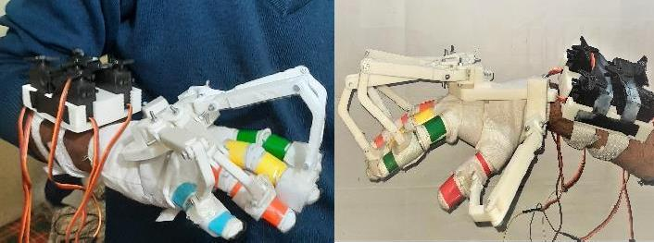

`



### DEPARTMENT OF MECHANICAL ENGINEERING INDIAN INSTITUTE OF TECHNOLOGY, KHARAGPUR

5

**Evaluating Haptic feedback from Augmented Reality Models through Image Processing and Fuzzy Control**

Haptic Interaction in Human Computer Interfaces for *Product Design Services*

Prof. Goutam Chakraborty Department of Mechanical Engineering Indian Institute of Technology, Kharagpur [goutam@mech.iitkgp.ernet.in](mailto:goutam@mech.iitkgp.ernet.in)

Utkarsh Sharma

Department of Mechanical Engineering Indian Institute of Technology, Kharagpur [utkarsh9992@gmail.com](mailto:utkarsh9992@gmail.com)

Mihir Sampat Department of Mechanical Engineering Indian Institute of Technology, Kharagpur

[mihirsampat19@gmail.com](mailto:mihirsampat19@gmail.com)

***Abstract*—Digitization of the industry has reformed the entire product market. With the introduction of virtual and augmented reality, their technical applications in product services have opened new doors to the layout of how we approach engineering design practices. The potential that virtual and augmented reality posses as a tool to explore designs and product features have no bounds. These technical features when further aided by haptic technology further narrow the gap between real and virtual elements. These services, however, are not cost-efficient solutions that can be readily employed by the common man. They require expensive setup and hardware that operate on heavy processors to function. Through our research, we aim to propose a cost-effective, ergonomic yet adaptable solution that can be deployed without any high capital or computational capabilities. In our paper we present a solution to provide augmented reality services through image processing and haptic feedback response. The project operates on Unity and Python and our haptic controller is actuated through an Arduino Uno microcontroller. The project’s fabrication estimates within 100 US$ and a detailed breakup is mentioned at the end of the paper.**

***Keywords - haptics; augmented reality; product; fuzzy logic; image processing; mamdani approach; vuforia; human computer interaction; design; customer services***

1. INTRODUCTORY BACKGROUND

Augmented reality is one of the current most versatile fields in engineering. Over the years, the increased adoption of augmented reality services in the product industry has reflected the importance of subsequent interface designs for these service applications. Various researches in the domain of haptic interactions in Cyber Physical Systems have innovated and developed customary algorithms and technologies advancing to revise our approach to reduce the bridge between the real and virtual environments.

In the engineering design industry, new design optimization techniques surfaced, and engineers started to seek out for much better design solutions that not only provide the ability to read and alter the blueprints but also aid the user in understanding the design geometry to the root and simultaneously suggest improvements in the existing models. A need to remodel the visualization technology was taken in consideration, and this marked the beginning of the virtual era which could support CAD features.

Although augmented reality originated as an incentive to make the motion picture experience more lucrative, engineers

realized the potential it had to operate as a CAD viewer. It provides the flexibility to the user to experience the real sized dimension aspect of the design and even on an advanced setup may feature with an ability to interact with it. Designers should be able to freely operate editing functions, adjust design parameters and explode their assemblies to fine tune their analysis. In conclusion, a virtual dynamic environment proves to an efficient yet cost effective measure to the current agenda of engineering design.

The temptation to interact with augmented reality models has led to research proposing new means of interface technologies that employ haptic feedback to network between the real and virtual elements. Often, these approaches are restricted to virtual reality setups and cannot be implemented directly for augmented reality models without replicating the real-world elements with their respective dynamic vectors. Even though we can use a vector point solution for interaction feedback for augmented reality models, which currently virtual reality models employ, the task to generate a feedback response through point vector algorithms is not only computationally expensive but is neither an accurately efficient nor cost-effective solution. And if the number of surfaces in the low poly mesh of the models is sufficiently complex and quantitively staggering, then the algorithm will simply fail to compute feedback on the same frame captured. This can be adjusted by localizing the contact regions and adjusting more sensors, but it would simply increase the net computation time, hardware costs and feedback delay Thus, we aim to propose a cost effective and computationally efficient solution that can drastically reduce feedback delay while trading off with run time accuracy within a threshold.

Currently, image processing solutions are being tested with Augmented Reality [1] but not much in haptics. Through our approach, we aim at developing a solution design that is adaptive, robust, cost efficient and ergonomic simultaneously.

1. IMPLEMENTATION PIPELINE

In order to develop the product technology for an ideal haptic feedback response, our course of action must identify the implementation pipeline blocks along the service routine. Detailing it objectively, we schedule our steps in order as designing the augmented reality model of the object of interest, creating an image feedback of the same for necessary

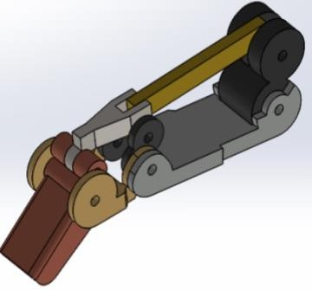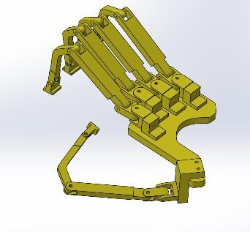

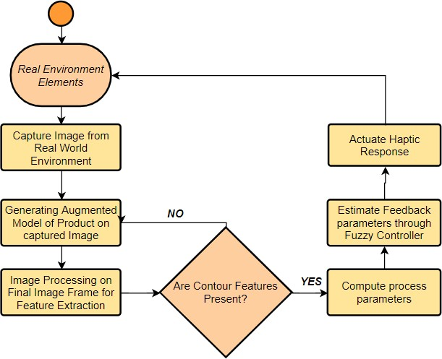*Figure.1 Implementation Pipeline of Solution Model*

processing, developing an algorithm to determine the action rule base through a Fuzzy Logic Controller, to actuating the feedback response through a haptic controller. The reader can refer to “Fig.1” to understand the approach better.

1. *Haptic Controller Design (Synthesis)*

Haptic controllers redefine the interaction between real and virtual elements through implementation of either tactile or kinesthetic actuators [7]. While tactile actuators recreate the skin membrane contact response through air pressure and diaphragm actuators, kinesthetic actuators provide force feedback on the user’s skeletal frame to reshape the sensation of obstruction as that of a touch. The controller under consideration for this study is a kinesthetic actuator that is designed while keeping the flexion features of the human finger grip in consideration. We first initiate our design to replicate a non-invasive exoskeletal frame, proposed to be supported and guided along the fingers. The resultant geometry is a 2-loop linkage sequence of 4-bar mechanisms, with the initial joint serving as the reference frame, as shown in “Fig.2a”. Since we have integrated our design to subtly feature along the dimensions of a human finger, we determine the remaining link lengths directly through Freudenstein

* 1. *(b)*

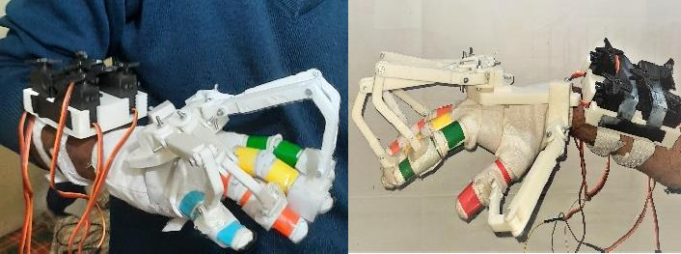

*(c)*

*Figure.2 Haptic Actuator Design (a) 4-DOF flexion (b) Current 6-DOF Skeletal (c) Final 3D-printed Assembly*

effect as being obstructed by a virtual object. The haptic skeletal was 3D printed on Polylactide (PLA). The mentioned design, however, was not that ergonomic and dynamically fluent, as the setup was heavy and the rotation between the links was guided very specifically which prevents the spherical mobility of the finger joint. Revising on the aforesaid design, we kinetically synthesize that instead of creating any albeit mountings for finger guiding [6], we can take the fingers themselves into our kinematic geometry, as member links of their subsequent 4-bar mechanisms as shown in “Fig.2b”. This drastically supports the design topology and even enables us to provide additional mounting for synthesizing the effects of the spherical finger joint through 3 additional revolute joint mountings This results in a 6-bar linkage of which again we directly estimate the link lengths through relations of 6 bar linkages as Watt II mechanism [2], with intermediate phalange as link 3, which is as follows:

∑ 𝐾2 − 1 + 2 ∑ {𝐾 𝐾 𝑐𝑜𝑠(𝜃 − 𝜃 )} = 0

relations [3] of 4 bar linkages as:

𝑖=1,2,4,5,6 𝑖

𝑖,𝑗=1,2,4,5,6

𝑖 𝑗

𝑖 𝑗

*(2a)*

*cos (θ4- θ2) = K1 cos(θ4) + K2 cos(θ2) + K3 K1 = l1 / l2; K2 = -l1 / l4*

*K3 = (l 2 + l 2 - l 2 + l 2) / (2 l2 l4)*

*1 2 3 4*

*(1a)*

*(1b)*

*. (1c)*

*K1 = l1 / l3; K2 = - l2 / l3; K4 = l4 / l3; K5 = l5/ l3; K6 = l6 / l3*

*(2b)*

1. *Generating Augmented Reality Models*

CAD models need to be extracted as low poly mesh files

For one loop in “Fig.2a”, from “Eq.1”, we obtain *l4* and *θ4* (link 4: finger phalange directly connected to ground reference of our hand) directly from manual measurements and we compute the rest through the equations as above and proceed through same iterations for the second loop. The rotation of the linkages is actuated through a servo controller, “Fig.2c”, (Servos MG995 6 Volts; Processor Arduino Uno; Link Connector Nylon wire line; UMPS 5 Volts 20 Amperes) that obstruct the flexion of the finger joints & creates a kinesthetic

in order to be replicated as an augmented reality element. In product applications we extract poly mesh files (fbx format) for the subject of interest and import it into Unity for further processing. Virtual mapping of a feature model obligates a reference frame for its scaling and point vector generation. When an augmented reality model is to be generated, an image target is selected as the reference and the point vector of the feature model is scaled about this image target. The virtual model can adjust its orientation when the image target itself is rotated by evaluating the position shifts in the reference axis.

Vuforia package, by Unity, is an online source extension written in JavaScript that easily generates image targets for recreated low poly mesh augmented reality models [5]. The online development platform provided by Vuforia is used to generate Image Targets which are then imported into Unity to function as reference axis for the augmented reality poly mesh to be generated. Functions such as disassembling the prototype can easily be encrypted into the service application on accounts of creating different augmented poly mesh animations for the same image targets.

1. *Extracting Feature Descriptors (Image Processing)*

Through feature descriptors we identify the contact regions and pass feedback evaluation criterions between the virtual and real elements. We redirect our approach to create contours over the real and virtual elements to identify contact regions and the course of action. The objective, to identify and evaluate regional overlapping of the haptic controller contours and the augmented model contour, is achieved through image processing. Prior to adjusting the haptic controller setup over the hand palm, we cover our hand with a glove of white fabric on which every individual finger has their own sets of unique identifiable color wraps (small DC vibration motors are also attached to it for creating an effect like tactile feedback.). This approach enables us to not only distinguish the actuating finger or the finger in contact with the virtual element contour, but also enables us to evaluate the degree of flexion to be supported by estimating the number of overlapped sets and passing the data into a Fuzzy Logic Controller. We take our images along the horizontal plane at two mutually perpendicular axes.

Implementing image processing concerns identifying correlation among a vast variety of parameters. The resulting frame developed in Unity inclusive of the virtual augmented element is stored as an image matrix for processing. Our application exercises the OpenCV library on Python where we are relaying the resultant Unity frames continuously through PIL library. Every image matrix stored must be mapped from their default BGR values to their respective HSV values. Since image processing involves a lot of filter operations for color and edge detection algorithms, we can generate noises if we fail to identify different shades of the same color, hence we convert the image matrix to HSV, prior to any operation.

After dilating the HSV matrix with a one’s kernel, we create thresholds for filters masking out every potential region of interest for the respective colors. We create filters for every individual color on the wrapped glove and that of the virtual element. We then compute bitwise AND operation with the main image frame with every color filter to map out only the regions of interest, namely the augmented reality model and every individual finger band on the haptic controller setup. The processed image is accounted for contour identification, where we employ the tree retrieval algorithm which retrieves all the contours and reconstructs a full hierarchy of nested contours [8]. We identify a minimum and maximum threshold scale for the contour region area to eliminate any external disturbances and noises. Though the solution model is not perfectly accurate compared to the vector mappings of virtual

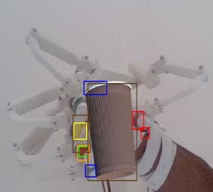 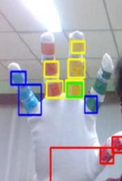

*Figure 3. Contour Mapping of processed image frames*

elements, it is significantly faster on a common processing hardware and is successfully able to generate the feature properties which can be further fed to the Fuzzy Controller for actuation.

1. *Fuzzy Logic Controller (Feedback Algorithm)*

After computation, once we have received feature properties of overlap from the two independent images, we now tend to correlate the flexion permits we can design for the controller*.* Individually every finger has its own sets of color wraps with their subsequent overlapping regions with the augmented reality model. We consider their overlapping regions as our regions of interest and detect for contour intersection by calling for bitwise AND operation and checking for a null matrix., and later we evaluate the contour region area of the mask and overlapping geometries through an inbuilt OpenCV function. We generate an input variable dependent on the overlapping of contours among the virtual element and the finger wraps as a probabilistic function. Contour intersection probability for color “c” when *‘i’* contour wraps of the given color overlap with virtual model is:

*pi(c)* = 𝐶𝑜𝑛𝑡𝑜𝑢𝑟 𝐼𝑛𝑡𝑒𝑟𝑠𝑒𝑐𝑡𝑖𝑜𝑛 𝐴𝑟𝑒𝑎 𝑜𝑓 𝑉𝑖𝑟𝑡𝑢𝑎𝑙 𝑀𝑜𝑑𝑒𝑙 𝑎𝑛𝑑 𝐶𝑜𝑙𝑜𝑟 𝐶

𝐶𝑜𝑛𝑡𝑜𝑢𝑟 𝐴𝑟𝑒𝑎 𝑜𝑓 𝐶𝑜𝑙𝑜𝑟 𝐶

0 ≤ 𝑝𝑖 (𝑐) ≤1

For the system modeling of the given controller, we follow a linguistic approach of Controller Modelling known as *Mamdani Approach* [4] which is characterized by its high interpretability and low accuracy. This approach is one of the most widely used system modeling algorithms in practice. The approach followed for our system design is as follows:

* The independent variables, namely the input membership function of probabilistic overlapping *p(c)* and the servo angle output for flexion control are identified.
* We measure the input probabilistic variable *p(c)* for a given color code overlapping pair (with one being the virtual model) and convert them into their corresponding fuzzy sets and plots as shown in “Fig.4a”.
* The fuzzified output is evaluated on the rule base, “Table. I” which in our case is Truth Value for the overlap of their respective contour sets. It is used to identify the number of true overlapping contours of the finger wraps when both the mutually perpendicular image frames are considered. If there

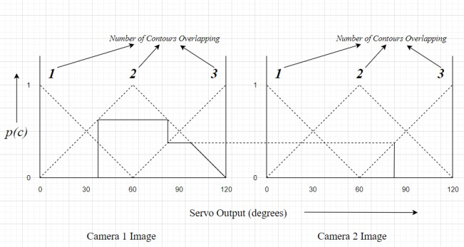 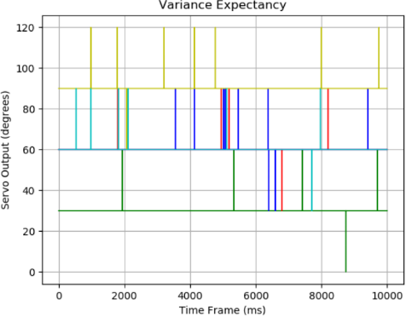

*Figure.4 Mamdani Fuzzy System Modeling for Feedback calculation*

TABLE I. FUZZY RULE BASE

|  |  |  |  |  |
| --- | --- | --- | --- | --- |
| **Output** | | **Contour Overlapping Image 1** | | |
| ***1*** | ***2*** | ***3*** |
| **Contour Overlapping Image 2** | ***1*** | 1 | 1 | 2 |
| ***2*** | 1 | 2 | 3 |
| ***3*** | 2 | 3 | 3 |

exists a possibility of 0 overlapping contours in any of the frames the net output is 0 and the controller has no control over the finger flexion.

* + We estimate the servo output from defuzzification of the estimated output, convert it into the closest multiple of 30 and actuate the servo for the corresponding finger through the microcontroller. It is essential to define the flexion output to a limited set of values to prevent rapid changes in servo output value due to contour overlapping noise

The servos actuate and pull the nylon wires at the evaluated angles to provide a kinesthetic feedback to out our skeletal. We receive a flexion suppression which can be rightfully accounted as the feedback that the augmented reality model has imposed on hand skeletal through haptic controller.

1. EXPERIMENTAL DISCUSSION

After generating the virtual element of the product in consideration, we consider the fluctuation in the feedback values that stem as we proceed along the frames. Even if the system is stable, the contours are very likely to shift their boundaries when capturing image frames. This may cause shift in the flexion angle for even the same image matrix when captured at different time intervals. A plot in “Fig.5” has been devised to compare the model accuracy and variance for a given augmented model when all elements may appear fixed in the video feed. Here we map the servo output fluctuations.

*Figure.5 Servo Signal vs Time, Fluctuation Records for Controller*

TABLE II. COST ANALYSIS

|  |  |  |  |
| --- | --- | --- | --- |
| **Sr No.** | **Product List** | | |
| ***Product Name*** | ***Quantit y*** | ***Net Cost (US$)*** |
| 1. | Arduino Uno R3 | 1 | 7.29 |
| 2. | MG-995 HT Analog Servo | 5 | 32.75 |
| 3. | PLA 1.75 Filament | 0.5 Kg | 19.18 |
| 4. | A862 12 MP Webcam | 2 | 11.89 |
| 5. | UMPS 5V 20Amp | 1 | 9.99 |
| 5. | Miscellaneous (screw, gloves, etc) | - | 10.00 |
|  | ***Total*** |  | ***91.10 US$*** |

1. REFERENCES
2. Babaei, Hossein Reza, Pagiel L. Mohurutshe and Arash Habibi Lashkari. "Image-processing with augmented reality (AR)." *International Conference on Graphic and Image Processing*. Singapore: Society of Photo-Optical Instrumentation Engineers, 2012. 5.
3. Eleashy, H. and M.S.Elgayyar. "Structural Synthesis of 6 Bar Mechanisms as Mechanically Constrained 3R Chains." *International Journal of Mechanical and Industrial Engineering (IJMIE)* (2012): 6.
4. Ghosal, Ashitava. "The Freudenstein equation: Design of Four- Link Mechanisms." *Resonance* (2010): 13. ResearchGate.
5. Lee, C. C. "Fuzzy logic in control systems: fuzzy logic controller. II." *IEEE Transactions on Systems, Man, and Cybernetics* (1990): 17. IEEE.
6. Liu1, Xinqi, Young-Ho Sohn and Dong-Won Park. "Application Development with Augmented Reality Technique using Unity3D and Vuforia." *International Journal of Applied Engineering Research* (2018): 4.
7. Pacchierotti, Claudio, et al. "Wearable Haptic Systems for the Fingertip and the Hand: Taxonomy, Review, and Perspectives." *IEEE Transactions on Haptics* (2017): 23.
8. Perret, Jérôme and Emmanuel Vander Poorten. "Touching Virtual Reality: a Review of Haptic Gloves." *ACTUATOR 18*. Bremen, Germany: ResearchGate, 2018. 6.
9. Suzuki, Satoshi and KeiichiA be. "Topological structural analysis of digitized binary images by border following." *Computer Vision, Graphics, and Image Processing* (1985): 15.

# Bachelor’s Project Spring Semester

## Design of an Adaptive Knee-brace to assist post arthroplasty locomotion

*Exobrace Design and Fabrication for rapid printing and assembly*

*Paper accepted at 4th International Conference on Biomedical Engineering and Biotechnology, Berlin (ICBEB 20)*

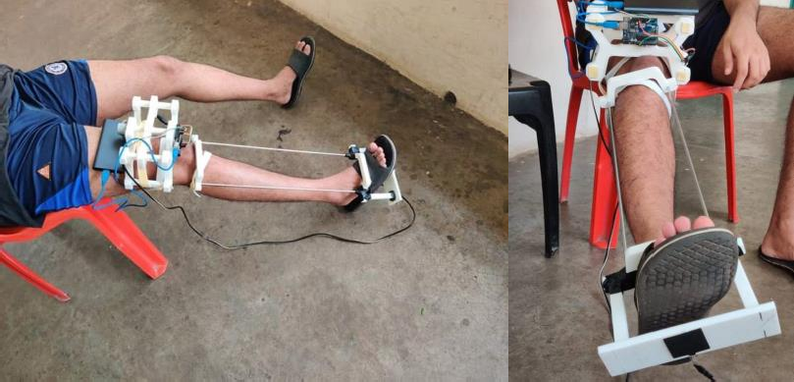



### DEPARTMENT OF MECHANICAL ENGINEERING INDIAN INSTITUTE OF TECHNOLOGY, KHARAGPUR

4

**Design of an Adaptive Knee-brace to assist post arthroplasty locomotion**

***Abstract: With the continuous improvement in medical technology, arthroplasty surgeries have become more frequent over the decades. DFMA (or Design for manufacturing and assembly) techniques are being adopted by the current generation of industrial engineers and product designers in order to provide more accurately detailed and robust solutions to the design requirements. Since modern Arthroplasty relies heavily on replacement prosthesis, it is essential to provide an external support source to allow the patient to accommodate to the current surgical changes in their body. It is an immediate requirement that, after total knee arthroplasty, the limb actuators during locomotion get external support from a framework or exoskeleton to distribute the loading of the reaction forces during every possible gait action. Since different gait cycles have different load distribution and frequency response for relaxation, it is necessary that an adaptive knee brace considering these parameters is designed for our patients.***

1. INTRODUCTION

A systematic design pipeline is very essential for increasing the overall efficiency in a modern product lifecycle. A designer should not only follow the necessary protocols to cover the essential features from the consumer forefront but should also be able to optimize their product in terms of failure reduction, material consumption, processing liabilities and other cost investment parameters from an industrial production outlook. Several products in the field of passive and quasi passive exoskeletons for arthroplasty patients have been designed over the years, but none have been fabricated from this necessary outlook.

Knee arthroplasty is one of the more frequent surgeries in patients with advanced osteoarthritis and is considered only in the exhaustion of other noninvasive conservative treatments. A series of universities, medical research centers, and arthroplasty professionals have emphasized the need to externally support the surgical structure of the patient for a detailed duration before their complete recovery. Limb-exoskeletons have been constantly being reviewed as potential performance enhancers in routine activities that centralize around body frame strength, endurance, and speed of action.

The applications of exoskeleton modules as framework support for arthroplasty patients, have initiated an immensely diverse research domain in the field of biomedical engineering and design. Modern rapid prototyping technologies have heavily restructured the manufacturing economy and its layout in the recent years. Product engineers are given the liabilities to design custom products with each being prototyped accordingly as per consumer requirements. Since every patient is unique, structural braces are required to be designed as custom fit essentials, and this is achieved through modern rapid prototyping processes like additive manufacturing, and 3D- printing.

It has been observed in medical records of TKA (or Total Knee Arthroplasty) patients’ post- surgery, that in due course of time, they experience notable decline in their accessibility to voluntary control their range of motion and they are able to clearly identify their lack of quadricep strength. It is therefore essential for us to design a structural brace or knee-brace to compensate for this loss in muscle strength, reduce pain or injury risk and improve coordination for a complete traversal activity.

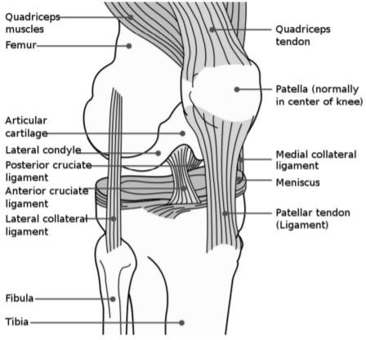

1. LITERATURE REVIEW

***Fig 1.*** *Anatomy of the human knee joint*

A thorough understanding of the analytical pipeline of the environment is very essential to assess the limitations and parameters involved in the fabrication cycle of our required product, in which it will be working. In our case, in order to proceed with a non-invasive design of the structural brace, it is necessary to first understand the anatomy of the knee joint, gather information on the loading limitations, generalize the kinetics for an individual and map the range of motion covered by the entire unit to understand the kinematics behind the unit assembly.

The knee joint (Fig 1.), is a synovial joint that primarily connects the *Femur* to the *Tibia* of the body frame, with several segments of muscle fibers and ligaments. The knee cap of the unit is covered with a flat bone, known as *Patella*, and it increases the leverage area to redistribute the loading of quadriceps tendons over the femur by increasing the solid angle of interaction. The knee also has a secondary ligament that generates a higher degree of contact of the *Fibula* against the *Tibia* to maintain structural orthodoxy. The knee covers a dynamic range from 20˚±10˚ to 150˚±10˚ of its flexion angle. The flexion is segregated into the ‘passive arc’, ‘active arc’, and ‘home flexion’ regions (also referred to as ‘screw home’ in some sources), that individually map the different stages of contact loading and muscle activity during locomotion.

Next, in order to understand the mechanical principles behind the assembly kinetics, it is required to define a series of parameters and equations that can be used to estimate the reaction moments and contact forces to compute the failure limits of our product under activity.

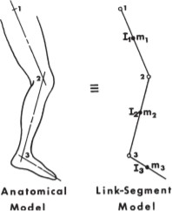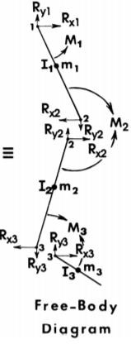

***Fig 2.*** *Link segment modeling, mapping reaction moments and forces*

Noninvasive estimations of the reaction moments and contact forces of the knee joint through inverse dynamics help us define the kinetics of the assembly through its structural kinematic analogy. They also help us compute the governing constraints through external dynamic quantities that can be assessed or mapped with an instrument or sensor. The process through which these estimates are calculated is commonly referred to as *link segment modeling* (Fig 2.)*.* We need to define the most adequate kinematic chain resemblance, that not only distinctively preserves the motion description of the joint but also records accurate anthropometric measurements.

The primary steps, that are an absolute necessity in mapping the anatomical model to its subsequent link segment layout, focus on the substitution of the knee joint axis with a concentric parallel revolute joint. They are also responsible to connect the links that correspond to the physical and dynamical properties (such as length, rotational inertia 𝐼0, center of mass) of the

*Femur*, *Tibia* and foot. We record failure parameter analysis and influence of segment parameters

by estimating ground reaction and contact forces in addition to their kinetic profile along the link segment model. Conservation of angular momentum and Newton’s second law of motion help us navigate, step by step, the reaction activity of the entire unit and the load distribution profile among the various ligament fibers. The governing equations for Fig. 2 that are enlisted to estimate the analogy dynamics are computed in the plane for both components of action as:

n

𝑚𝑥̈ = 𝑚𝑎0 + ∑ 𝐹𝑖

𝑥

(1)

i=0

𝑅𝑥2 = 𝑚𝑎𝑥 + 𝑅𝑥1 (2)

𝐼0𝛼 = ∑ 𝑀

𝑛

(3)

For the estimation of all essential dynamic quantities it is necessary to first record a measurement of all the kinematic variables involved, namely, displacement *x*, instantaneous velocity 𝑥̇, and instantaneous acceleration 𝑥̈ for the center of mass for a particular segment. It is also mandatory to simultaneously compute the angular displacement *θ*, instantaneous angular velocity 𝜃̇ or *ω,* and instantaneous angular acceleration 𝜃̈ or *α* between two connected limb segments. In order to compute the aforementioned dynamic relations, we estimate the kinematic variables as follows:

𝑥̈2 = 𝑥̈1 + 𝜔⃗⃗⃗⃗⃗1⃗⃗2 *× (* 𝜔⃗⃗⃗⃗⃗1⃗⃗2 *×* ⃗𝑟⃗⃗1⃗⃗2 *) +*⃗⃗𝛼⃗⃗⃗1⃗⃗2 *×* ⃗𝑟⃗⃗1⃗⃗2 (4)

𝑥̇2 = 𝑥̇1 + 𝜔⃗⃗⃗⃗⃗1⃗⃗2 *×* (𝑟⃗2 − ⃗𝑟1 *)* (5)

𝑑𝑥

𝑥̇ = 𝑑𝑡

(6)

Where, 𝑟⃗⃗⃗1⃗⃗2 =

⃗𝑟2 − 𝑟⃗1 , defines the position vector along the limb segment length directed from

point 1 to point 2. We substitute these kinematic relations to estimate the dynamic quantities mentioned in Equations 1.,2., and 3. The resultant external force on the system is represented by

∑n 𝐹𝑖 and resultant effect of all conservative field is represented as 𝑚𝑎 in Equa.1. The resultant

i=0 𝑥 0

contact reaction force in the direction, 𝑟⃗⃗⃗1⃗⃗2 is given by ′𝑅𝑥2 − 𝑅𝑥1′ for x-component of the force, and correspondingly a familiar equation represents the y-component of the force. We will get references from these equations for assessment of our controller feedback and prosthesis design.

1. LOCOMOTION SUPPORT BIOMECHANICS

In order to initiate the design for our exoframe, we should understand the different gait cycles and the stress distribution profiles through each of them. It is necessary to measure the knee flexion relationship for flexion and the moment generated for the individual cycles. In our definition, we will restrict with the primary locomotion cycles including walking, running and stair climbing. From the average flexion measurements recorded from multiple research subjects (Fig 3.), we can clearly correlate the pattern necessary to define the loading profile with respect to flexion angle during any gait cycle. If we are oriented to design a support exoframe, we should keep in mind the feature integrity necessary to adapt to all physical locomotion advances by the user. We cannot expect similar cycle frequency and moment profile generated through among the cycles from an amplitude standpoint.

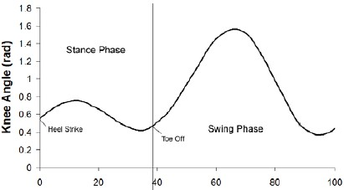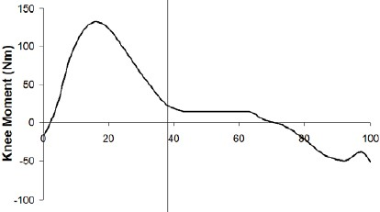

* 1. *Knee flexion and Moment during Running, respectively*

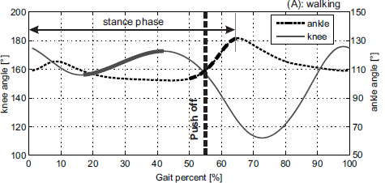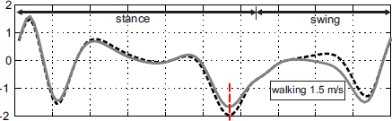

* 1. *Knee flexion and Moment during Walking, respectively*

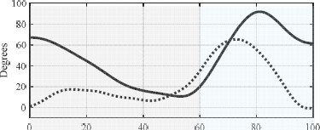 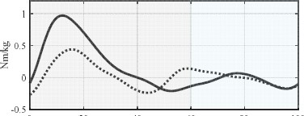

* 1. *Knee flexion and Moment during Stair climbing, respectively*

***Fig 3.*** *Knee joint gait profile during (a) Running, (b) Walking and (c) Climbing*

Hence it is recommended to design an adaptive bracing that can self-adjust the damping or impulse absorption tolerance accommodating to the user environment. As practice, most knee exoframe braces follow link assisted damping design (Fig 4.) for frame support. A channel or frame guide is designed to transmit the compressive quadricep force generated in the stance phase of the gait cycle, from the calf under muscle contraction to the thigh of the connected limb segment through a passive damper-spring actuator.

Every stance during a locomotion activity generates a necessity for skeletal balance. Since, the patient’s body is not equipped with the adequate knee rigidity to comply with the demand, it rests over the support from the additional force generated on compression of the damper-spring actuator. Collectively, shock or impulse absorption and frame support, both are assisted by this actuator, and designers are individually mapping these critics to the damping coefficient and spring stiffness coefficient of the actuator system respectively, according to their application requirements.

When necessary flexion is introduced through the Gait cycle, the kinetic energy during flexion is conserved and stored as potential energy that subsequently releases during the swing phase of the cycle. Overall, this actuator design significantly contributes for the additional moment required by the joint assembly. These designs, once installed *lack the adaptability* to adjust accordingly to individual requirements to micromanage individual gait profiles.

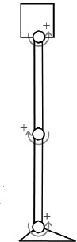 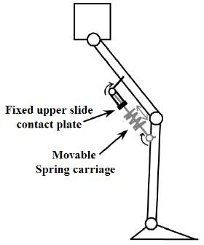 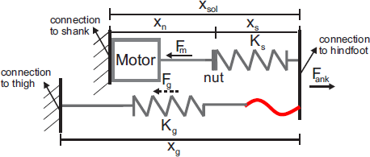

***Fig 4.*** *Current Link Assisted Damping Exobrace Design*

Additionally, there is no transit support provided to reduce the overall burden on the joint itself. A *transition relay is absent* to diverge the body weight loading from the knee joint, which is an absolute must in order to encourage joint recovery. So in order to design a desirable product that is adaptable to different locomotion cycles and reduces the overall knee joint loading, it is necessary to revise the existing design by including an external feedback based damper-spring actuator and an additional exoframe to channel the body weight through it to reduce to overall joint loading.

1. PRODUCT SOLUTION

Exobraces should be defined as distinctive wearables and accordingly should be designed as comfortable, lightweight and dynamic products to accommodate the user specifications. Instead of manufacturing the entire assembly from an alloy, we can substitute the core frame material with PLA (Poly lactic acid, Tensile strength 37MPa, Flexural strength 43MPa for 0.1 mm filament) that is easy to fabricated with modern rapid prototyping manufacturing machines. The mesh regions where more composite rigidity and yield strength is required will be supported by SS Alloy assembly components.

It is necessary to have a brace designed to adjust and support the limb segments and accordingly a frame structure to support the joint contact forces. Topology optimization algorithm encourages on conducting reiterations of the Von Mises stress profile simulations of the existing design under the pre-determined set of external conditions and requires the designer to substitute the stress hotspots with a material of higher yield strength.

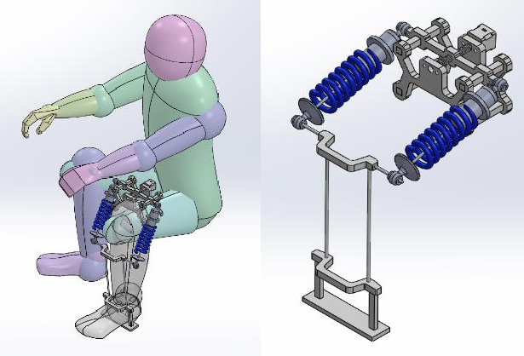

* 1. *CAD assembly of the Exobrace*

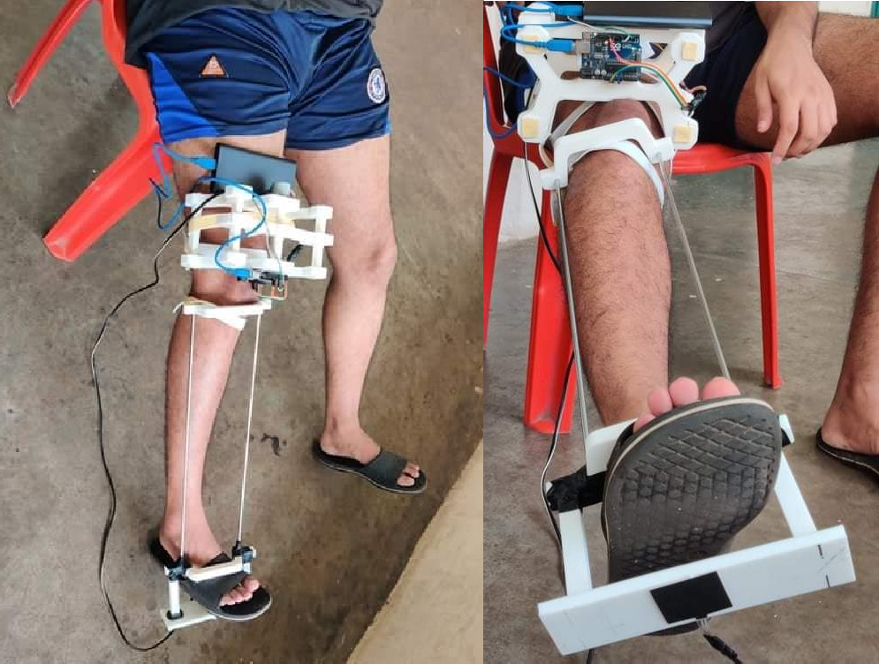

* 1. *Isometric and front view of the Exobrace*

***Fig 5.*** *Exobrace prototype and assembly*

It also encourages seam curvature over surface finishes to avoid edges and corners as much as possible in the current geometry and promotes removal of material from the regions where stress profiles are negligible in amplitude, to minimize product weight and reduce material consumption.

The design dependency of the variable stiffness actuator is dependent on the initial compression of the shock absorber. From Hooke’s Law it is clearly evident that every for every infinitesimal extension in the spring from its mean position a higher force is required. In every different gait cycle the reaction contact force is dependent on the weight of the patient and the non-referential acceleration during locomotion (pseudo force). Hence, more muscle activity is required to climb the stairs, rather than descending them. During running, the joint experiences more loading on the structure over walking. And cycling reflects as a period continuous reaction force dependent on the user’s throttle.

The damper-spring actuator joins the knee brace of the patient to their tibia brace, which is connected with a link segment bypass to the ground (Fig 5.; damper-spring delivery failed due to Covid-19 crisis). When the user stands, the actuator absorbs all impulses generated and minimizes the strain on the knee joint.

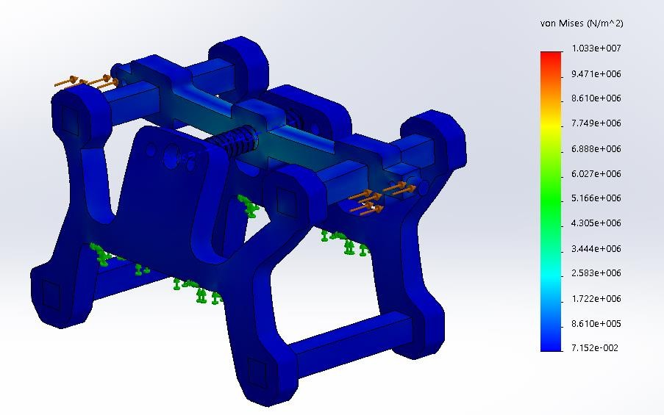

1. *Static Analysis-Von Mises Stress profile for composite design*

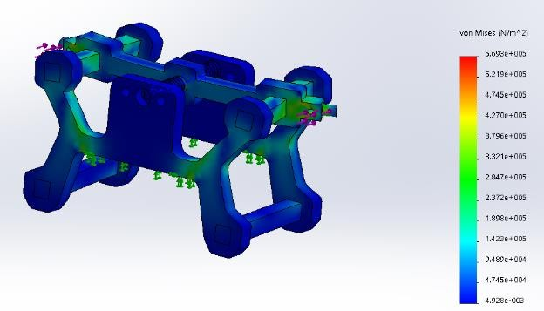

* 1. *Static Analysis-Von Mises Stress profile for SS alloy*

***Fig 6.*** *Simulation study for core replacement*

The segment connected to the tibia brace supports the shocks absorbed by the actuator by serving as a channel to dissipate energy stored in the spring actuator. The foot support has a FDR(or force sensor), to measure the reaction force from the ground, an encoder installed at the rotary joints estimates both angular displacement *θ* and instantaneous angular velocity 𝜃̇ . We substitute these parameters in the equations (1) – (6) and obtain the remaining values. The data is mapped to a threshold based function that determines the spring extension necessary for impulse reduction. A stepper motor circuit comprising of Nema-17(200 steps equals 1 revolution) with an 12V, 2A DRV8825 motor driver, and Arduino Uno R3 then proceeds to rotate the lead screw (M80x4) to shift the actuator joint position towards the front that in effect compresses the spring or vice versa.

The damper spring actuator not only functions as an assist to support gait loading, but also transfers the body weight from just quadricep slightly above the knee joint to directly the foot pivot. In the design study we also assess the failure limit for the cases (Fig 6.) through a simulation when the entire knee brace structure is fabricated from SS Al Alloy 6601 and compare it to a composite of PLA and the same alloy where the alloy is only employed at stress hotpots and rest of the brace is fabricated with PLA. This is an adaptation of Topology optimization and benefits wastage reduction and cost cuttings.

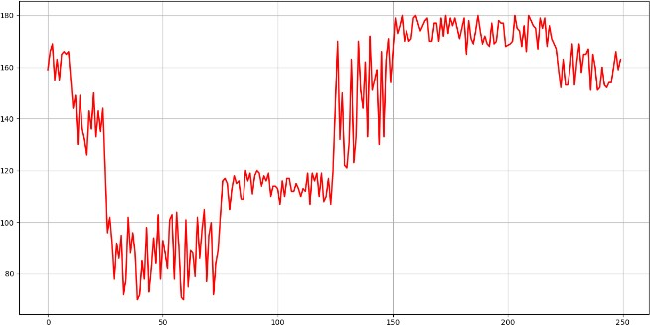

* + 1. *Encoder response for stair climbing*

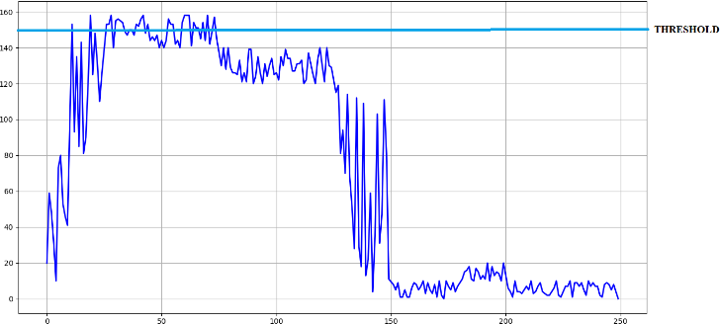

*(a) FDR response for stair climbing with threshold*

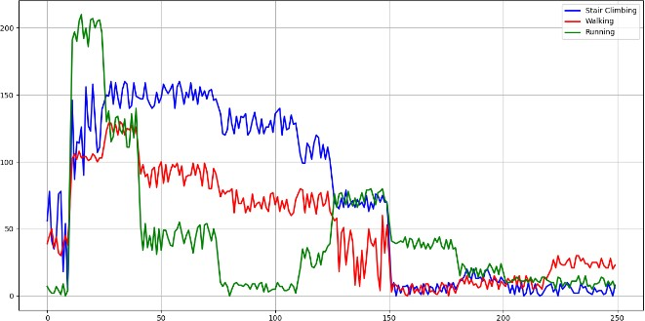

*(a) Comparative assessment for Threshold evaluation*

***Fig 7.*** *Prototype run results for Gait Cycle Analysis*

1. ANALYTICAL EVALUATION

In order to map the required compression with the corresponding locomotion activity, we use a multivariate function that is dependent on the force magnitude and the angular frequency as recorded by LDR and encoder respectively. We define a series of threshold for the time stamp and response output recorded for different gait cycles. There is no need to calibrate the force readings to their actual value, just distinctive mapping from (0,255) will be sufficient to note threshold after connecting the voltage divider circuit with it. We map the responses of both the sensors for the gait cycle and mark the frequency and force response.

As per data recorded (Fig 7. b), we use the principle of statistics to identify the threshold value, the local maxima are evaluated and its value is plotted for multiple iteration against iteration number to find the mean threshold (Fig 8.) of the model.

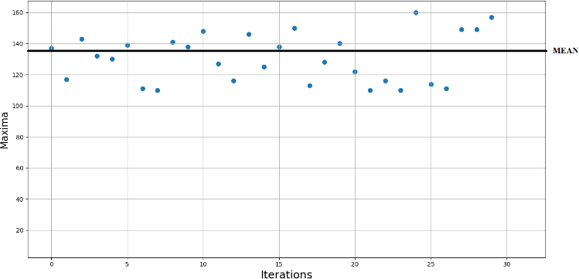

***Fig 8.*** *Threshold Identification for Stair Climbing*

Whenever the threshold is crossed for an activity, the stepper sets the spring compression to a proportional limit of the identified gait cycle. The frequency is estimated by setting a flag, as soon as the system crosses the threshold. All time intervals between the flag sets are recorded and averaged. A higher frequency would seek a lower spring compression, and a higher magnitude of reaction force would be balanced by a higher compression.

Thus we encounter a case of Multi objective optimization where the quantity *x (spring compression)* is a dependent on the ratio of the force magnitude and frequency. An empirical estimation is compiled in Table I, which was observed to be comfortable after multiple manual settings. The table record the value *directly* from the sensors.

1. CONCLUSION

Adequate compliance design has always been challenge from an aesthetic, functional and ergonomic standpoint. In gait compliance design, the commercial products that are adaptive to an external feedback always have an active control unit with either a hydraulic SEA, pneumatic cylinder drive or electromagnetic couplers to support the frame base. These designs, though are functionally superior than the proposed design, lack commercial affordability, DMF repeatability and the necessity ergonomics all together. Our suggested prototype primarily focuses on unification of these aspects to revamp the existing design approach of exoframes and exosuits.

In the aforementioned designed we reflected on the necessity and feasibility of an adaptive response system for the damper-spring actuator within certain thresholds accordingly for different gait cycles. The stiffness variability is determined accurately by the Central Control Unit of the device and it maps the control response of the system model in effect of the magnitude of the external loading on the load cell and frequency of the same. Some alterations are also necessary in the existing design, on one hand design failure can definitely lead to performance degradation.

Table I. Activity based compression

|  |  |  |  |
| --- | --- | --- | --- |
| Locomotion Activity | Average Threshold Force(bits) | Average Frequency (Hz) | Spring Compression  (stepper steps) |
| Running | 191.2 | 6.1(8kmph) | 1410 |
| Walking | 117.4 | 2.7(5kmph) | 1180 |
| Stair Ascent | 158.9 | 1.4 | 1850 |
| Stair  Descent | 134.3 | 1.9 | 1620 |

Table II. Component List

|  |  |  |
| --- | --- | --- |
| Component | Specifications | Quantity |
| PLA Filament | 1.75 mm dia | 800 grams |
| Stainless Steel rod | 5mm, 25cm | 2 |
| Lead Screw | 80x4mm,  10cm | 1 |
| Damper-Spring Actuator | 90 KN/m | 2 |
| Force Dependent Resistor | 38.1mm,  square | 1 |
| Arduino Uno | R3 | 1 |
| Nema17 Stepper Motor | 200 steps,  12V | 1 |
| DRV 8825 Motor Driver | 2A, 12V | 1 |

Since the aforementioned concept of Exobrace is currently designed from PLA, it cannot be expected to have high resistance to external deformation and is thus more prone to fatigue failure over long term use. The parts however are relatively very affordable to reprint and replace the worn out or broken components. The entire brace is very easy to assemble and worn and if the user has the resources to replace the core material from PLA to Polycarbonate or Carbon fiber, that have flexural strength over 6 times that of PLA, a higher tensile strength (72MPa PC,37MPa PLA) and more durability, we can achieve much better results from the assembly frame as a complete product.

It is important that design adjustments should be introduced by scaling the assembly dimensions according to each individual patient. Misalignment of the links should be minimized as much as possible and the designed should be operated in only as sub-optimal manner to prevent product failure and unconformable irritation to the user.

THANK YOU

1. REFERENCES
2. R. Ezzibdeh, P. Arora, and D. F. Amanatullah, “Utilization of a pneumatic exoskeleton after total knee arthroplasty,” Arthroplasty Today, vol. 5, no. 3, pp. 314–315, Sep. 2019.
3. J. E. Pratt, B. T. Krupp, C. J. Morse and S. H. Collins, "The RoboKnee: an exoskeleton for enhancing strength and endurance during walking," IEEE International Conference on Robotics and Automation, 2004. Proceedings. ICRA '04. 2004, New Orleans, LA, USA, 2004, pp. 2430- 2435 Vol.3.
4. A. M. Dollar and H. Herr, "Design of a quasi-passive knee exoskeleton to assist running," 2008 IEEE/RSJ International Conference on Intelligent Robots and Systems, Nice, 2008, pp. 747- 754.
5. M. Eslamy, M. Grimmer and A. Seyfarth, "Adding passive biarticular spring to active mono- articular foot prosthesis: Effects on power and energy requirement," 2014 IEEE-RAS International Conference on Humanoid Robots, Madrid, 2014, pp. 677-684.
6. Y. Liao, Z. Zhou and Q. Wang, "BioKEX: A bionic knee exoskeleton with proxy-based sliding mode control," 2015 IEEE International Conference on Industrial Technology (ICIT), Seville, 2015, pp. 125-130.
7. N. B. Bolus, V. G. Ganti, and O. T. Inan, “A 3D-Printed, Adjustable-Stiffness Knee Brace with Embedded Magnetic Angle Sensor,” in 2018 40th Annual International Conference of the IEEE Engineering in Medicine and Biology Society (EMBC), 2018.
8. Z. Zhang et al., “Lower Extremity Exoskeleton for Stair Climbing Augmentation,” in 2018 3rd International Conference on Advanced Robotics and Mechatronics (ICARM), 2018.
9. G. Fekete, “Kinetics and kinematics of the human knee joint under standard and non-standard squat movement,” Ghent University and Szent István University, Gent, Belgium, 2013.
10. S. Grosu et al., “Driving Robotic Exoskeletons Using Cable-Based Transmissions: A Qualitative Analysis and Overview,” Applied Mechanics Reviews, vol. 70, no. 6, Nov. 2018.
11. D. A. Winter, “Biomechanics and Motor Control of Human Movement.” John Wiley & Sons, Inc., 23-Sep-2009.
12. T. Mangera, F. Kienhöfer, K. Carlson, M. Conning, T. Purkis, and G. Govender, “Design for manufacture and assembly of a polycentric paediatric prosthetic knee,” Proceedings of the Institution of Mechanical Engineers, Part B: Journal of Engineering Manufacture, vol. 233, no. 14, pp. 2566–2576, Apr. 2019.
13. E. Rogers, P. Polygerinos, S. Allen, F. A. Panizzolo, C. J. Walsh, and D. P. Holland, “A Quasi-Passive Knee Exoskeleton to Assist During Descent,” in Bio systems & Bio robotics, Springer International Publishing, 2016, pp. 63–67.